Name : Tushar Pathak
RegNumber : 230905396
Roll Number: B48

Lab 1: Introduction to execution environment of MPI

Q1)Write a simple MPI program to find out pow (x, rank) for all the processes where 'x' is the integer constant and 'rank' is the rank of the process. Write a program in MPI where even ranked process prints "Hello" and odd ranked process prints "World".

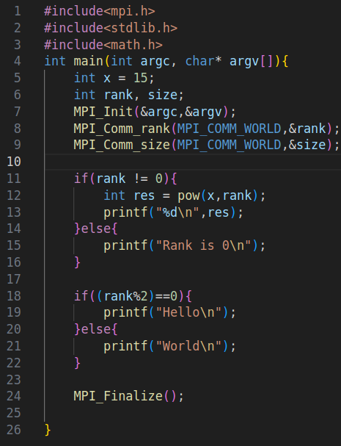
Code:

Output:
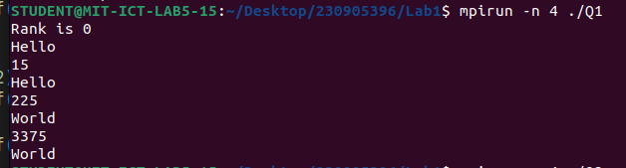

Q2) Write a program in MPI to simulate simple calculator. Perform each operation using dif- ferent process in parallel.

Code:
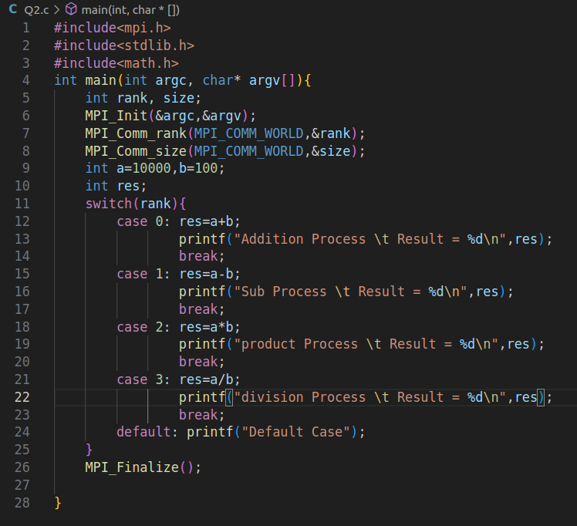

Output :

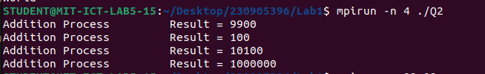

Q3) Write a program in MPI to toggle the character of a given string indexed by the rank of the process. Hint: Suppose the string is HELLO and there are 5 processes, then process 0 tog- gle 'H' to 'h', process 1 toggle 'E' to 'e' and so on.

Code:

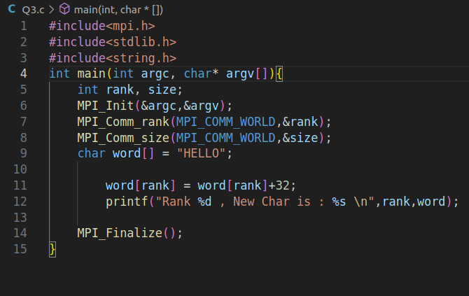

Output :
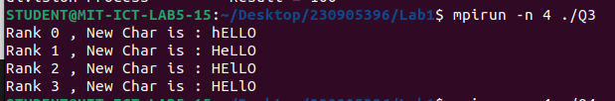

Q4) Write a program in MPI where even ranked process prints factorial of the rank and odd ranked process prints ranks Fibonacci number.

Code:
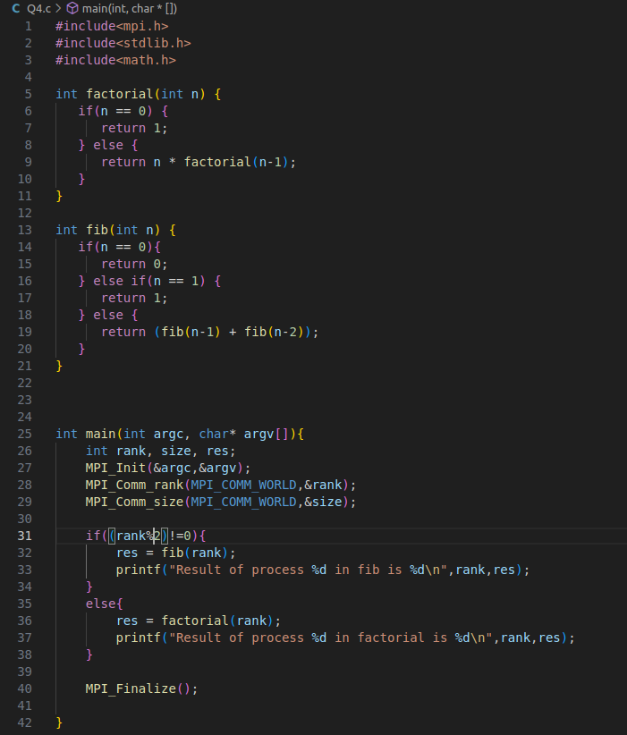

Output:

